**Introduction to Software Engineering**

**CSE291**



Department of Computer Science

COMSATS University Islamabad, Lahore Campus

**Lab Name:** Introduction to Software Engineering Lab.

**Lab Code:** CSE291

**Semester:** 3rd

**Lab Week 2 & 3**

**Tasks**

1. Prepare Project Proposal according to given template
2. Explore MS Project tool
3. Task division using Gantt Chart and make the Gantt Chart by using MS Project

Style Guidelines for Final Year Project ReportsPROJECT PROPOSAL TEMPLATE



Department of Computer Science

COMSATS University Islamabad, Lahore Campus

20 September 2021

**Project Details**

|  |  |  |  |  |  |  |  |
| --- | --- | --- | --- | --- | --- | --- | --- |
| Type (Nature of project) | | | [ ] **D**evelopment [ ] **R**esearch [ ] **R**&**D** | | | | |
| Area of specialization | | |  | | | | |
| **Project Group Members** | | | | | | | |
| Sr.# | Reg. # | Student Name | | CGPA | Email ID | Signature | Obtained Marks |
| (i) | Group Leader |  | |  |  |  |  |
| (ii) |  |  | |  |  |  |  |
| (iii) |  |  | |  |  |  |  |

**Project Title:**

**Aim of the Project:**

The aim of the work, i.e. the overall purpose of the study, should be clearly and concisely defined. Aims: Are broad statements of desired outcomes, or the general intentions behind the project, which 'paint a picture' of your project

**Problem Statement:**

Overview of problem and propose Solution

**Limitations of Existing System**

The limitations sections of your proposal describe situations and circumstances that affect or restrict the already present system functionalities. Limitations are influences that affect the overall working of system.

**Project Introduction/ Project Description:**

Describe your project in detail

**Project Objectives:**

The project objective describes the projects: outcomes intended and direct, short- and medium-term effects on the target group. The project objective must lie within the scope of the project

**Individual Tasks:**

Please mention your individual tasks in-group project justifying one-year effort.

**Time Schedule/Gantt Chart:**

As per individual tasks mentioned in previous section, the Gantt chart shall graphically represent which tasks would be done in which duration i.e. starting date, end date etc. What tasks shall be done in parallel and what tasks shall be done in series, etc. Duration of individual task. (View few sample from internet before making your own to get ideas)

**Example:**

**Project Title:**

Hostel Management System

**Aim of the Project:**

Aim of Hostel Management System is to create a program, which is used in Hostels to keep record.

**Problem Statement:**

The old system of keeping records in hostel was paper file system. On which records are kept in a paper file by hand. There were many problems such as security, slowness, calculation errors, storage place, backup of records etc.

**Limitations of Existing System**

Lack of security of data.

Time consuming.

Consumes large volume of paper work.

Manual work

To avoid all these limitations and make the system working more accurately it needs to be computerized.

**Project Introduction:**

This project can be used in hostels to store records of hostellers in database, to display the saved records with printing facilities. This software is totally secure with password-protected facility. The administrator can create new user, update them when required and delete them if not necessary. The administrator staff can utilize all the facility provided by the software and all the guest staff can get some of the facility.

**Project Description:**

It is a small software package, which is helpful in the areas of Hostel. This program package includes all the activities in which the hostel is managed. The activities like hosteller admission, fee payment, inventory purchasing, report generating, etc. will be included.

Users can simply add record, delete them, update them, send email, create Backups of the Database, and many more using this software. User need not have to think about where the data should be saved or from where we can retrieve it. All the data are saved automatically in the defined place and are retrieved from there directly by using this software. No computer trainings or experts are needed to handle this software.

In terms of security, this software is totally secure as it does not give access to unauthorized users as the username and password facility is provided.

To achieve the above objectives, the following major activities will be under taken:

·         Design the module with good interface. Coding in good interface design with logic.

·         Testing and troubleshooting is done for each section individually, combined to form, and finally tested.

·         References, teachers and websites are regularly consulted.

·         User manuals and documentation of the project are done throughout the project.

**Project Objectives:**

The objectives of this project are as follows:

* To manipulate the Hostel transactions with instant confirmation.
* To save time and accuracy in work.
* To increase efficiency of employee..
* For secure and smooth running of the program.
* For error free, effective and easy for database related works.
* Indicate the room availability and the location of the rooms.
* If the visitor is satisfied with the room location, then confirm the booking;
* Print the payment details and other necessary constraints.

**Time Schedule/Gantt Chart:**

|  |  |  |  |  |  |  |  |  |  |  |  |  |  |  |  |
| --- | --- | --- | --- | --- | --- | --- | --- | --- | --- | --- | --- | --- | --- | --- | --- |
| ACTIVITIES | December | | | | January | | | | February | | | | March | |  |
|  |
| Problem Analysis |  |  |  |  |  |  |  |  |  |  |  |  |  |  |  |
| Proposal submission |  |  |  |  |  |  |  |  |  |  |  |  |  |  |  |
| SRS |  |  |  |  |  |  |  |  |  |  |  |  |  |  |  |
| System Modelling |  |  |  |  |  |  |  |  |  |  |  |  |  |  |  |
| Coding & verification |  |  |  |  |  |  |  |  |  |  |  |  |  |  |  |
| Testing |  |  |  |  |  |  |  |  |  |  |  |  |  |  |  |
| Integration |  |  |  |  |  |  |  |  |  |  |  |  |  |  |  |
| Final testing |  |  |  |  |  |  |  |  |  |  |  |  |  |  |  |
| Documentation |  |  |  |  |  |  |  |  |  |  |  |  |  |  |  |
| Final presentation |  |  |  |  |  |  |  |  |  |  |  |  |  |  |  |

**HOW TO CREATE GANTT CHART**

**Create a Task List for the Microsoft Project Timeline**

The first step in building a Gantt chart is to create a list of required tasks. Try to prioritize the tasks in the order they need to be completed.

1. Open Microsoft Project and click Blank Project.
2. Add the list of tasks for the project to the Task Name Column.

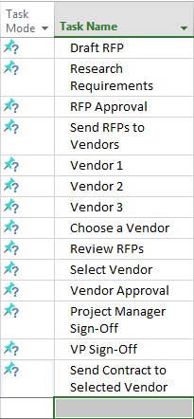

**2.     Provide Start and Finish Dates for Your Timeline**

Now that your tasks are added, you need to provide start and finish dates for each one in the project.

1. Click on the Start cell for the first task.
2. Enter the start date by clicking on the arrow in the box and selecting it from the calendar or enter the dates manually.
3. Enter the end date for the task by clicking on the corresponding Finish cell. Click the arrow in the box to select a date from the calendar or enter the dates manually.
4. Leave the Duration cell empty, Microsoft Project will automatically populate the amount of days the task will take.
5. Complete Start and Finish dates for all other tasks in the project.

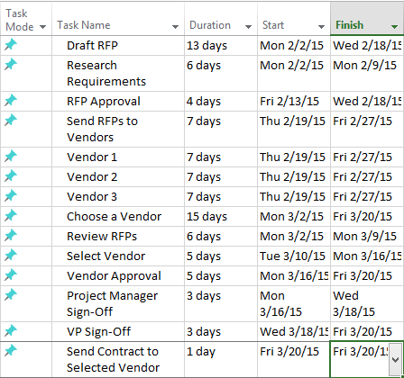

**3.    Group To-Dos Together that Pertain to a Single Task**

The benefit of grouping tasks together is that you are able to collapse or expand the specific steps required to complete a phase of the project. This can help track a particular part of a project and help you identify dependencies.

First, you will need to create sub-tasks.

1. Create a sub-task by clicking on the rows of tasks that relates to a specific phase of the project. These tasks should be listed under the project phase. In this example, click and highlight Research Requirements and RFP approvals. To add multiple rows, hold down the Shift key as you click each row.

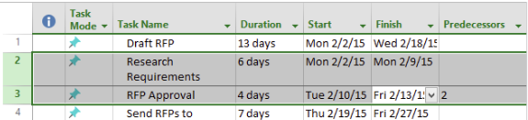

1. Once the rows are highlight, click the right indent icon in the ribbon bar. Once you click the indent icon in the ribbon bar, Research Requirements and RFP Approval will become sub-tasks of Draft RFP.
2. Use the same steps to create sub-tasks for the entire project.

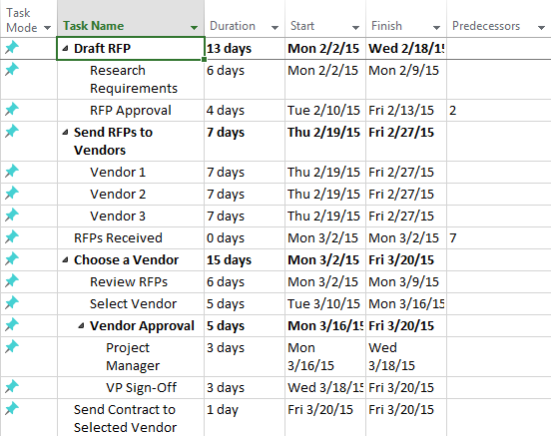

**4.     Add Milestones to the Timeline**

Milestones are a great way to see if the project is running on schedule and to signal the end of a particular phase.

1. Create a Milestone by adding a new row, putting it where you want it to appear in the timeline. Click the row to add a Milestone.
2. In the Task tab, click the Milestone button in the ribbon bar.

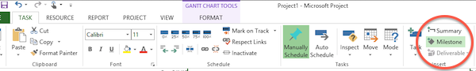

1. Click in the cell that has New Milestone and type a name for the Milestone. The Milestone will appear as a diamond on the Gantt chart.

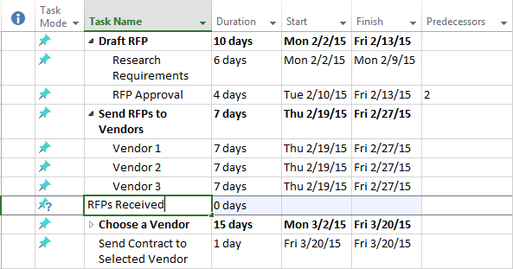

**5.     Link Related Tasks to the Milestone**

Once you have added a Milestone, you will want to link it to the Task that has the complete date.

1. Click on the Milestone in one row and hold the Shift key down while clicking on the task(s) you want to link it to.

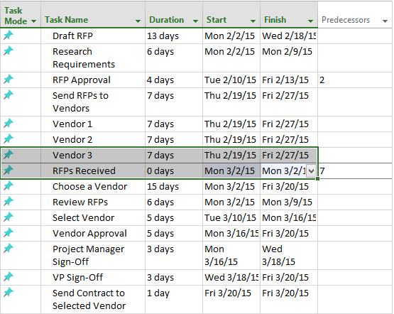

1. Click the link icon in the ribbon bar to link the tasks. You can also link other Tasks together by following the same steps.

**6.     Turn on the Microsoft Project Timeline Feature**

If the timeline feature is not automatically turned on (if it is activated, you will see a blank timeline above the Gantt chart), you’ll need to manually turn it on. 

1. Click on the View Tab. Then click the box next to Timeline in the ribbon.

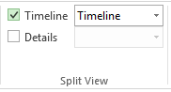

**7.     Add Tasks to the Microsoft Project Timeline**

Once the Timeline feature is activated, you can add your tasks to it. Once you add these items, you can also customize how the information is displayed by assigning colors and adding/removing titles. 

1. Click on the task to add it to the Timeline.
2. Right-click on the mouse and click Add to Timeline. The task will appear on the Timeline.

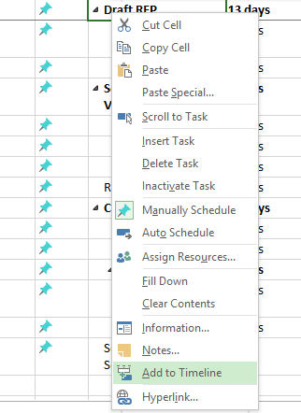

**Use the Copy Picture tool to export Gantt chart for your word**

Now you need to create an image you can paste into Word, PowerPoint. Microsoft Project has a feature called the Copy Picture tool, which allows you to choose which tasks you want to show in your visual. This is useful for paring down project tasks to the ones that are critical for your presentation.

1. On your Task list view in Microsoft Project, select all the Task rows you want displayed in your image (hold CTRL + click to select each item). In the example below, I selected all my Summary Tasks rows.
2. On the **Task,** tab drop down the Copy button to find the **Copy Picture** control.
3. Choose to render image as a **GIF file**.
4. Choose to Copy **Selected Rows**.
5. Set your timescale and click **OK**.